DTSC 671: AI Solutions in the Cloud

SUBMISSION TEMPLATE:
Sentiment Analysis with Amazon Comprehend

Select File > Make a copy to edit the template and add your screenshots. Download the completed template as a PDF document to submit to Brightspace.

In every screenshot, include your AWS username that appears in the upper right corner. Example:

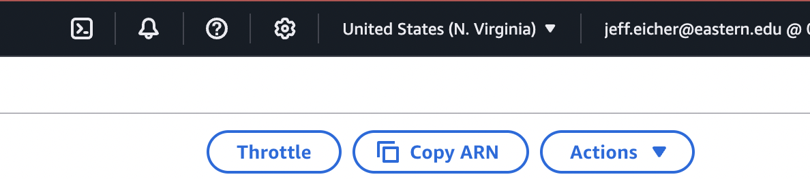

If any one screenshot is missing this identification, the entire assignment will be scored no higher than 70%.

Points totals are provided at the start of each question. You score either full credit or 0 points; there is no partial credit for each question.

- [10 points] In the space below, provide a screenshot of the SQS queue.

- [10 points] In the space below, provide a screenshot of the SNS topic.

- [10 points] In the space below, provide a screenshot of the Lambda diagram, which shows the SQS trigger and the SNS destination.

- [10 points] In the space below, provide both a screenshot of the beginning of your Lambda code with your account showing, then copy-paste your full lambda code below the screenshot.

- [10 points] In the space below, provide a screenshot of the CloudWatch log streams for your Lambda function. Fit as many as you can in the screenshot.

- [10 points] In the space below, provide a screenshot of the CloudWatch stream that functioned without errors for the Lambda function.

- [10 points] In the space below, provide a screenshot of the review you are testing in the SQS queue.

- [30 points] In the space below, provide a screenshot of the email you receive showing both the text of the review and the sentiment (positive, negative, neutral).

